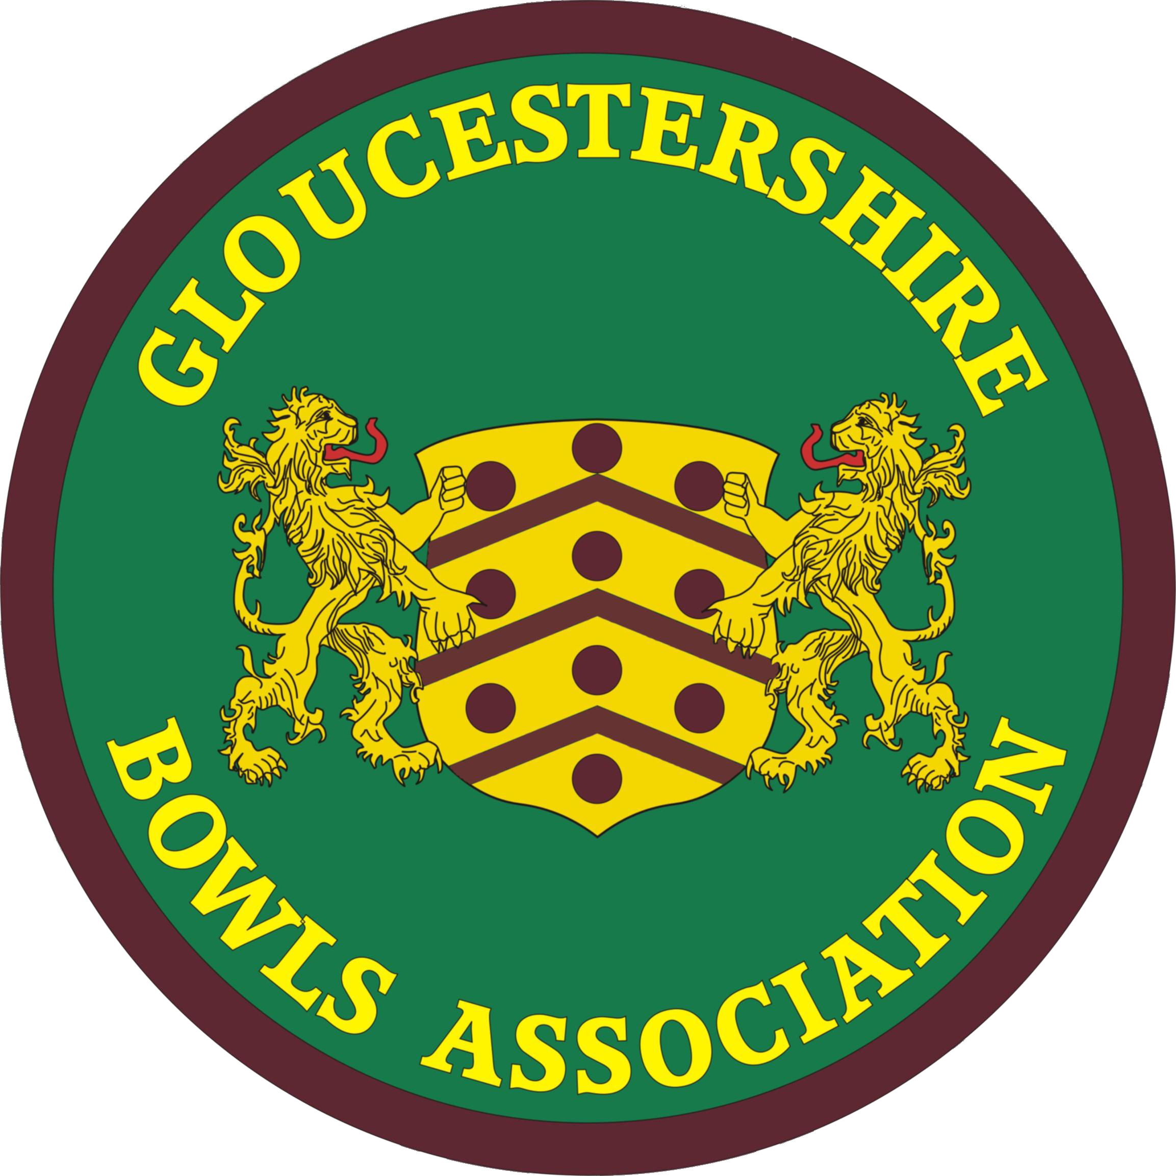 | GLOUCESTERSHIRE BOWLS ASSOCIATION  A Member of Bowls England
G.B.A Joint Executive Committee
Saturday 16 April 2022 : 10.00 am : Falcon BC

Participants : Committee Chair - David Rolls (MD Representative) DR, Committee Secretary - Lindsay Collin (County Administrator and WD BE Delegate) LC [online only], Myra Savage (GBA Match Secretary) MS, Pat Yates-Whittaker (County Treasurer) PY-W, Angela Cary (Deputy County Treasurer) AC, George Thomas (Deputy County Administrator) GT, Val Molton (Co-opted WD Representative) VM, Craig Guthrie (MD BE Delegate) CG, Roger Harrison (GBA Deputy Match Secretary) RH

- Apologies Linda Bennett (WD Representative), Les Hanley (Deputy County Treasurer) LH

- Executive Committee Chair introduction DR

Welcome. Thanks for the appointment.

- Minutes of Joint Executive Meeting of Saturday 12 February 2022 [ Circulated ]

Accepted as a correct record. Ratified

- Matters arising from 12 February minutes (not otherwise on the agenda) DR

4.1 [Items 6.1 and 6.2] What is sublimation ? VM explained and showed the new County Match Shirt to members.
4.2 [Item 6.4] Online purchases directly through Karuta not yet active. Hopefully shortly.
4.3 [Item 10.4] Chair exhorted all JEC members to take decisions on a whole-Association basis, as suggested, not with a divisional perspective.

- Update on new uniform acquisition 2022 (relates to next item, but see Item 8 also) VM/LC

5.1 After an introduction by VM, LC described the various stages in the acquisition of the new County Match Shirt and other uniform items, including the recent sizing difficulties with the Women’s shirts (first delivery), which are being resolved. WD will now hang on to all shirts, including the incorrectly-sized ones. VM and LC will arrange the actual distribution of the shirts for the WD, Ian Gauld and Graham Phillips for the MD.
She presented a brief summary of the payments made to Karuta thus far (document circulated) and the way in which these had been covered, including loans from the WD, MD and herself. It was essential that the situation in relation to where the money was coming from, including payments yet to be collected from individual men and women players, was understood. Also that this would relate to the total levy to be deducted prior to distribution of the May 2022 Affiliation monies to the MD and the WD (see item 6.4).

- Key financial matters LC

  - Account update
The Administrator gave an update on the GBA2010 account. Current balance £2483. This now includes some of the initial Affiliation payments from clubs, which serves to obscure the situation; these amount to £2170, which is 4 clubs’ Affiliation payments. 2022 GBA2010 payments owed still outstanding total £1012 (2 officer allowances, Web hosting, account examination).
  - County Treasurer
PY-W was due to take over as of today as the new County Treasurer, but this will now delayed slightly, due to LC’s absence in person today. The present Affiliation exercise will from now onwards be a joint operation, with the Administrator compiling and administering the membership database, the County Treasurer dealing with all payments (as soon as the appallingly slow Barclays Bank get themselves sorted). Big annual exercise, but data and money must be complete by end of May. However, as much of an imperative for the Administrator is the need to advise all Competition Secretaries of all the Affiliated players in all clubs, as early in May as possible, for checking ‘legality’ of competitors.
Signatories on the GBA2010 account would now be PY-W, LC, LB and DR, at least until the May 2022 Affiliation process is complete. LC will have to pay in a lot of cheques relating to uniform purchases made by individuals selected for the John’s Trophy and Middleton Cup squads.
  - 2022 Affiliation process
7 returns so far, out of 57. But only two weeks to go. Submission of Club numbers must be by 1 May at latest, to the Administrator, and payment of monies as soon as possible after that, to the County Treasurer. Final submission of data, with payment, to Bowls England, by 31 May. After this, the distribution of monies to Divisions can be made, subject to the levy being deducted initially. Concern expressed by Chair and wondered if any action by others could help ? Administrator said that she would be reminding clubs several times in the final two weeks and felt that she would get it done !
  - Divisional Levy
This had already been discussed at some length in the 12 February JEC meeting, with the various components listed. The same basic financial commitments must be covered by a basic levy of £1.00 per head already agreed (which would produce around £3000) : GBA Club Handbook printing (£560 this year); annual payment for Web-hosting (circa £70 per annum); GBA Administrator allowance (£700); coach for GBA mixed game (£500); Data Protection registration (£35); insurance (£100); subscription to Friends of English Bowling (£100). Total £2065.
A couple of items had not been listed at that time : County Treasurer allowance (£100); account examination (unknown, previously £120, but say £150); room hire £74; this year, Disciplinary case costs of £294. Taking the total to £2728.
However, this does not include the £2000 loans from the two Divisions for purchase of new shirts, so another approx £0.60 per head would be necessary, so that those loans can be repaid. Chair asked Administrator about GBA2010 cash-flow and whether it was an ongoing problem, but Administrator thought otherwise in a ‘normal’ year. Proposed by Chair that the levy for this year should be £2.00 per head; agreed by the Committee.

- Schedule F : Greens Committee Protocols. Update GT

7.1 GT had circulated a redraft of the Greens Committee (GC) Protocols, which he went through and explained :
- Protocols not working at present; Committee not meeting. Not enough greens inspection. Lack of enthusiasm
- Not all members have direct greens maintenance background
- Has talked with County Greens Advisor Mark Savagar
- Looking at changes in the protocols. Includes for new greens (as at Churchdown). Best advice needs to be available to clubs
- Quality of greens most important for competitions
- New clauses 9 and 10 relate to the authority that the GC has. Quick action is sometimes paramount. Protocols also need to be more widely known
7.2 A wide-ranging and quite lengthy discussion then took place, which included reference to some of the following points (from various Committee members and in no particular order) :
- Noted that the qualifications of GC members are not necessarily that high; sometimes just playing experience, not actual greens knowledge
- ‘Reports’ used to be posted in clubs whose green had been inspected
- What authority does the GBA, or the JEC, actually have to dictate to clubs ?
- Wider review of role of Greens Committee required
- GC should have an active Chair, to take the lead
- A ‘process’ for inspections needs to be laid down
- Difficulties in dealing with greens contractors
- Mark Savagar needs to be more centrally involved, if possible
7.3 Decided that we cannot change things immediately, but that a meeting of the Greens Committee should be held, with many matters to be discussed. We are looking at taking things forward and improving the situation. GT will take responsibility for convening a meeting, as soon as practically possible, but with 2023 in mind, though the GBA must still be able to deal with any 2022 issues that might arise.

- Future of County Match Shirt, re use by whole Association GT

8.1 LC referred to the Minutes of the MD Delegate Meeting on 26 March, where the men had revisited the proposal that had been supported in their 21 October 2021 Delegate Meeting, that consideration should be given to a new County Shirt for use in all County games. Though this was already included in ‘things to do’ for the JEC. GT then elaborated on what happened in the most recent MD meeting :
- Strong feeling in meeting for adoption of a single shirt for all County games
- Some reference to ‘elite-ism’
- Issues :
  - How would ‘changeover’ be managed ?
  - Is a questionnaire the way forward, as suggested by MD ?
  - Costs a very significant issue
  - Interlinked with still persuading people to play for the County ?
8.2 A long discussion ensued, which considered many aspects of the subject :
- This discussion is getting confused with the recent decision that the new shirts are supplied in recognition of County Match players attaining that competitive inter-county level
- Questionnaires are actually very difficult to devise and the data even more difficult to then objectively analyse
- Whole subject is potentially somewhat divisive. There will always be someone who doesn’t like or want to accept the outcomes. Some people will welcome a new shirt, some will use it as an excuse to not make themselves available in future
- What is the remit of the County, as against the Divisions ? County must make the decisions (through the JEC), as main outcomes must apply to the unified county across the board. JEC should not necessarily dictate to Divisions how the decision(s) are implemented and how shirts would be funded (?) Could subsidies be used to make the cost of shirt as low as possible and thus not put people off ?
- Divisional dress codes mentioned. Ideally, these should be identical and would need to be for mixed games. But that will not be the case next year, for known reasons. Quite big differences in views evident between Men and Women, in relation to ‘below the waist’ options
- None of this could possibly be decided for 2022, so maybe we aim for 2023. Use this season for all County players to see the new kit and that might change a few minds (or not ?)
8.3 The Chair suggested, and all agreed, that he write directly to the MD Secretary and Chairman explaining the thinking that had taken place and indicating a possible and practicable way forward .

- Constitution review process DR

The Chair felt that the previous two agenda items had taken so much time, that there was no possibility of dealing in even an introductory way with the Constitution review process, in the remaining time. As 15 October is so far away, agreed that a meeting should be convened in June, possibly July. Secretary charged with finding a date agreeable to the members of the Committee. Pointed out by her that most weekends in June taken up with competitive inter-county matches, so a weekday evening has to be an option.

- Safeguarding GT/DR

10.1 GT brought a suggestion from the Men’s Division Delegate Meeting that the GBA consider having a single Safeguarding Officer at the County level, rather than each Division having one. A brief consideration by the Committee lead to the unanimous acceptance of this proposal (note that this would involve changes in the Constitution). In part driven by the fact that both roles are currently vacant. Though there are a significant number of GBA members who have gained the required BDA qualification, most are functioning purely as Club Safeguarding Officers and not offering to help at the County level.
By a co-incidence, however, the Administrator had received an offer to become the Women’s Division Safeguarding Officer, only two days previously, this being made by Jude Vidler (Cheltenham BC). Jude has considerable relevant background and qualifications in Scouting and another sport (golf), plus recent Bowls qualifications. She understands that the role would be the next level up from the clubs – to respond to anything that is escalated to the County level (and across the whole Association). She has also agreed to work with the Administrator to consider both the procedures needing to be documented and also the publicity needing to be put out for clubs about those procedures.

- Bowls England Report

11.1 BE Annual General Meeting LC
    - New President is Terri Keen (Bucks), after 2 years of Paul Robson (Hants), himself now IPP. SVP Deepak Tanna (Leicestershire), JVP David King-Taylor (Nottinghamshire).
    - All fees – Affiliation and competition entry - remain unchanged for yet another year. Affiliation now the same since 2005 !
    - Three propositions all voted upon and passed :
      - Reinstatement of badge presentation ceremony at Leamington
      - John’s Trophy to become a ‘Round Robin’ competition again in 2023
      - Reinstatement of Bowls England Presentation Dinner (one, unified) in November 2022
- Presentations on ‘Pay to play’, ‘New introductory bowls format’.
11.2 Competition update. Championship and National Competitions, Inter-County
- Tabulation of total entries per county, 23 March (cIrculated). Gloucestershire Men +19.6 %, Women +4.9%, Overall +15.8%
- National Competition draws, released on 4 April
- Numbers of qualifiers per county for the National Finals, still awaited. This will tell us how many qualifiers Gloucestershire has in each actual competition. Probable that men will have two in everything, but that women will again have only one, possibly losing even the one event where they had two last year.
11.3 BE Awards Evening LC/VM
The inaugural Bowls England ‘Awards Evening’ took place. Reservations by JEC on all sorts of aspects of this new development, previously expressed to Bowls England via the Administrator, but Gloucestershire did embrace this new idea on the inaugural occasion.
Pleased to say that we had three nominations in two categories, the premier one being the long-established and prestigious ‘Bowls England Club of the Year’ for which 2 Gloucestershire clubs made the shortlist of 5 (Bristol St Andrews BC; Kingswood & Hanham BC). Peter Jones - Bristol St Andrew's BC – was shortlisted in ‘Story of the Year’ category). Kingswood & Hanham scooped the ‘Club of the Year’ award. Well done to them !
  - Big Bowls Weekend 2022 VM
- 27-29 May 2022
- Registration still open, online
- VM very willing to offer advice to clubs. Suggests clubs limit periods offered and book people in for particular times
As an aside, Bowls England were with K & H this week for a few hours, talking to new members from last year’s BBW, and experienced hands too, for a ‘Club Life’ piece on the club that will appear in the BE Web site in the near future.
11.5 National trial nominations
Confirmed recently (by Alistair Hollis) that no decision has been made yet about whether any nominations will be asked for this year. Gloucestershire Men’s Division Team Manager is upset about this. Combination of Covid and the Commonwealth Games seems to have cancelled the 6 rink, 24 player teams for the British Isles events being considered, in favour of 12 men/12 women teams, playing singles, pairs, triples and fours.
11.6 Regional Finals
It should be noted that two Gloucestershire clubs, Kingswood & Hanham BC and Cotswold BC, have been awarded BE Regional Finals Days – K & H the Walker Cup, and Cotswold the Balcombe Trophy, both on Sunday 17 July 2022.

- Handbook/Yearbooks update LC/GT

All in hand now, with only a handful of clubs still not yet having had their GBA Club Handbooks and divisional Yearbooks (their fault !)

- GBA mixed fixtures – any changes RH/MS

Nothing significant.

- GBA Annual Luncheon LC

Sunday 23 October. Everything in hand. Circulation will take place in July.

- AOB

15.1 Leamington tickets for nominated County officers. Shortly to be circulated asking for those who might be interested.
15.2 New shirt permission for Moreton in Marsh. Passed.

Meeting closed at 12.00 pm

Date of next regular meeting - Saturday 15 October 2022 - 10.00 am - Falcon B.C

